1. A working data pipeline (code/scripts or notebook) that performs ingestion, cleaning, transformation, and loading. (Notebook to be clean and have proper markdowns)
File name : Angel Blessy.ipynb

3. A Power BI report/dashboard (.pbix and screenshot) with meaningful KPIs and interactive visuals.
Attached document :
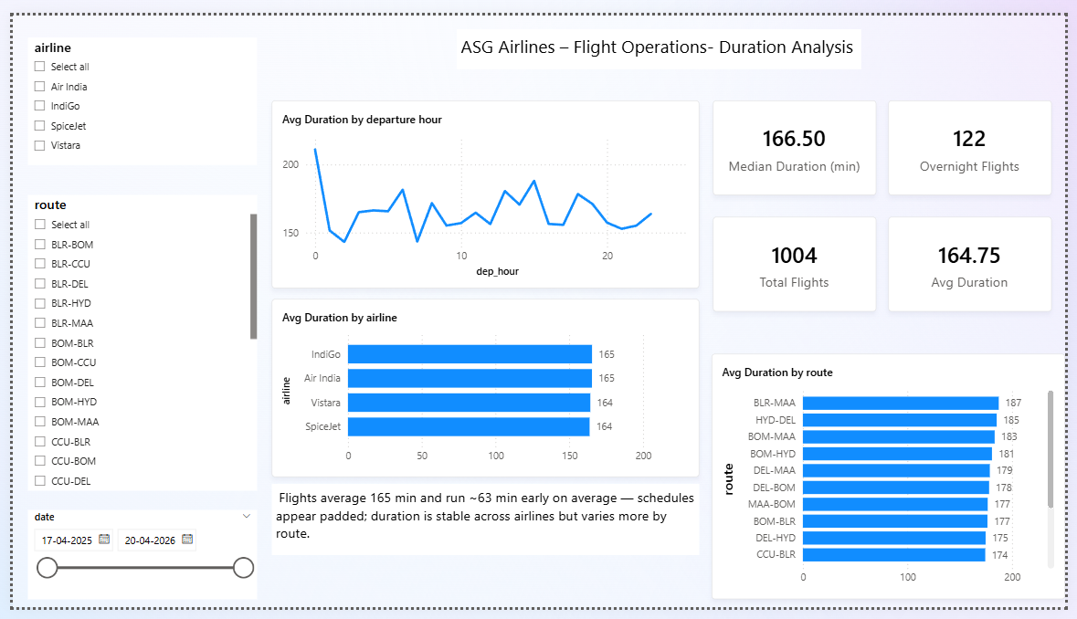
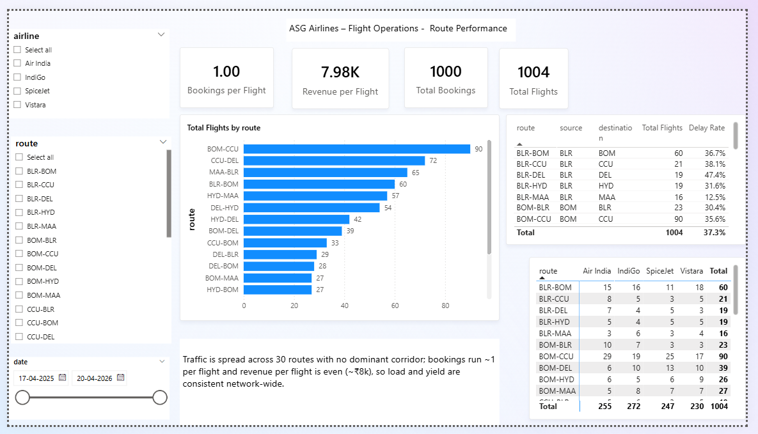
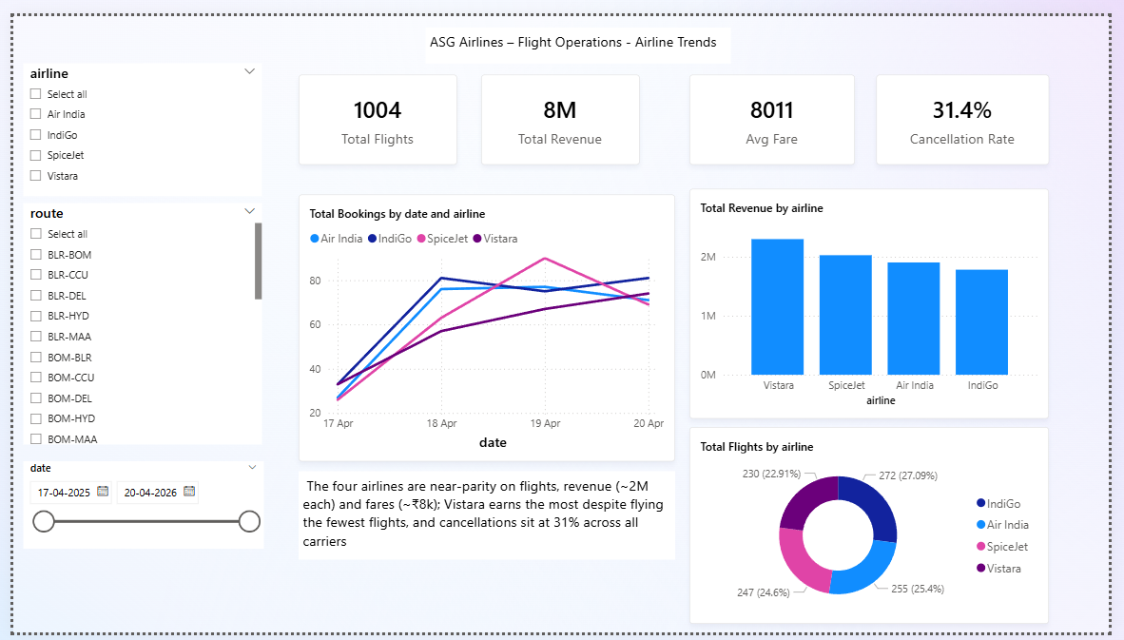
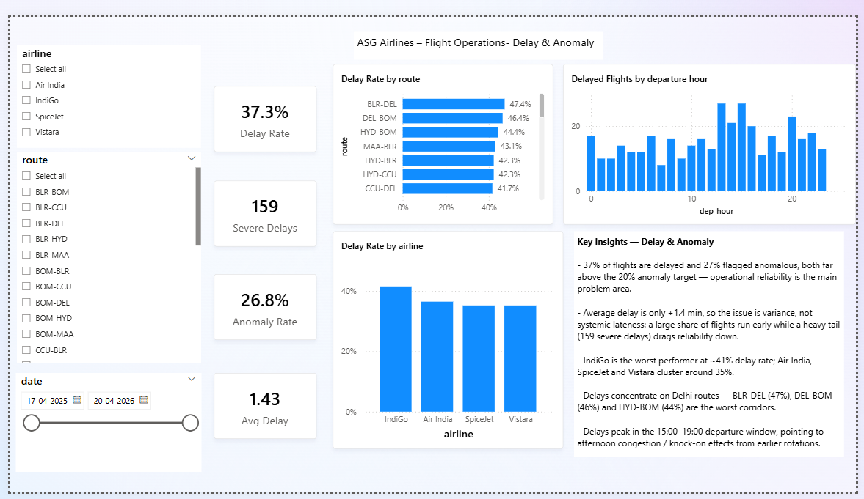

3. Provide a clear descriptive walkthrough of the complete workflow, with detailed explanations of the architecture, data flow, and overall solution design.
The walkthrough is spread across this document, the diagrams in diagrams/, and the markdown cell above each code cell in Angel_Blessy.ipynb. Together they explain the four-layer architecture (bronze, quarantine, silver, gold) and why each layer exists, then follow the data as it moves from the source workbook through ingestion, cleaning and modelling into the Power BI report, covering the assumptions, the cleaning and transformation rules, the KPI definitions, and how passenger PII is protected.

1. Code Implementation
- Write scripts/code to implement the complete data pipeline.
Built as a single notebook, Angel_Blessy.ipynb, with 40 code cells across three tasks: ingestion into a bronze layer, cleaning into silver, and modelling plus KPIs into gold. It reads the source Excel workbook (four sheets) and writes Parquet and CSV outputs into layered folders. The run is idempotent, so re-running simply overwrites its own output.
- Ensure the pipeline performs ingestion, transformation, validation, and aggregation efficiently.
Ingestion reads every sheet as text so no value is auto-converted, attaches data quality flags, and separates clean rows from rejected rows into a quarantine folder. Transformation standardises values, rebuilds real timestamps, rolls overnight arrivals to the next day, recomputes duration, removes duplicate keys, imputes missing values, and hashes passenger PII. Validation runs referential-integrity checks after both bronze and silver. Aggregation builds a star schema of 5 dimensions and 3 facts, plus 16 KPI tables written as CSV for Power BI.
- Include proper error handling and logging wherever applicable.
A console logger prints what each step did and the row counts it touched. Format and type problems, such as non-numeric amounts, unparseable booking status and missing keys, are caught in the quality check and are then flagged, quarantined with a reason, or imputed instead of stopping the run. Every issue type and its row count is saved to data/dq_report.csv, and the before and after row counts are saved to data/cleaning_summary.csv.
- Candidates may use tools/frameworks such as PySpark, SQL, Azure Data Factory, Databricks, Python, Fabric, or equivalent technologies.
Implemented in Python using pandas, PyArrow for Parquet and openpyxl for the workbook, so the whole pipeline runs locally with no cluster. The bronze, quarantine, silver and gold layout and the pandas logic port directly to Databricks later: pandas becomes PySpark, Parquet becomes Delta, and the local folders become a Unity Catalog volume.

2. Dataset Documentation
- Describe the structure of the flight dataset.
The source workbook has four sheets: flights, passengers, bookings and payments. Flights holds flight_id, a two-letter airline code prefix, route, departure and arrival time, reported duration and an airline name that is often blank or UNKNOWN. Passengers holds passenger_id plus personal fields (name, email, phone, Aadhaar, passport, date of birth, emergency contact). Bookings links a passenger_id to a flight_id with a status, and payments links an amount and method to a booking_id. The exact columns kept in each cleaned table are visible in data/gold and in the notebook.
- Document all preprocessing and transformation logic applied throughout the pipeline, neatly in a Word Document, including:
Every preprocessing and transformation rule is described in the markdown cell above the code cell that performs it in Angel_Blessy.ipynb. The points below summarise what that covers.
- Architecture diagram, Data Flow Diagram and Data Model
All three are in diagrams/ as PNGs (architecture.png, data_flow.png, data_model.png), with their Mermaid sources under diagrams/src/. The architecture diagram shows the bronze, quarantine, silver and gold layering; the data flow diagram traces the workbook through ingestion, cleaning and modelling to the Power BI report; the data model shows the star schema of 5 dimensions and 3 facts with its keys.
- Assumptions made
There are no scheduled times in the source, so delay is measured against the median duration of the same route (more than 30 minutes over is delayed, more than 90 is severe). Airline is filled from the two-letter flight-code prefix where it is missing or UNKNOWN. A missing surname and an unparseable booking status become UNKNOWN, and missing or non-numeric payment amounts are set to the median fare. Date of birth is dropped because an age column already covers it.
- Data cleaning logic and strategy
Rows are not deleted silently: only a missing key or a fully duplicated row is quarantined, and the reason is kept with it. For a repeated flight_id or passenger_id the row with the fewest blank or placeholder fields is kept, with ties broken by original source order. Text fields are trimmed and airport, status and payment-method values are upper-cased. Referential integrity is re-checked after cleaning so every foreign key still points at a real parent row.
- Transformation steps and logic (including duration calculation and overnight flight handling)
Departure and arrival strings are parsed into real timestamps. When the arrival falls before the departure the flight crossed midnight, so the arrival is pushed forward by one day. Duration is then recomputed as the actual arrival-minus-departure gap in minutes, replacing the reported value. Departure hour, delay minutes against the route median, and the is_delayed, is_early, is_overnight, is_severe_delay and is_anomaly flags are all derived from these cleaned values.

Evaluation Criteria

1. Functionality
- Does the solution satisfy all operational and transformation requirements?
Yes. All four tasks in the brief are implemented in one notebook: ingestion, cleaning, star-schema modelling with the required KPIs, and a Power BI report on top.
- Is the data pipeline functioning correctly end-to-end?
Yes. The notebook runs with no errors and rebuilds every bronze, silver and gold output in a single pass.
- Are flight durations and KPIs calculated accurately, including overnight scenarios?
Yes. Arrivals before departure are rolled to the next day and duration is recomputed from the corrected timestamps; the report visuals match the gold KPI files exactly.

2. Scalability and Performance
- Is the chosen architecture scalable for larger flight datasets?
Yes. The bronze, quarantine, silver and gold layering and the pandas logic port directly to Spark: pandas to PySpark, Parquet to Delta, local folders to a Unity Catalog volume.
- Are transformation and aggregation processes optimized efficiently?
Yes. Work is done in vectorised pandas operations, each layer is written once as columnar Parquet or CSV, and the run is idempotent so it can be safely re-executed.

3. Data Quality and Governance
- Were data quality issues (corrupted identifiers, time inconsistencies) handled correctly?
Yes. Missing keys and exact duplicates are quarantined with a reason, duplicate ids are collapsed to the cleanest row, and overnight or negative durations are corrected before modelling.
- Was passenger PII information protected appropriately?
Yes. Name, email, phone, Aadhaar, passport and emergency contact are salted SHA-256 hashed before the silver layer and date of birth is dropped, so no readable personal data reaches Power BI.
- Were business rules implemented consistently?
Yes. Delay thresholds, the airline-from-code-prefix rule and the imputation rules are applied uniformly to every row and documented in both the notebook and the Word documentation.

4. Creativity and Attention to Detail
- Did the candidate implement additional enhancements beyond the basic requirements?
Yes. Added a quarantine layer, a full dq_report and cleaning_summary, 16 KPI tables (well beyond the four asked), anomaly detection and referential-integrity checks.
- Is the dashboard visually appealing and business-friendly?
Yes. Four themed pages with consistent KPI cards, synced slicers, a custom theme and a plain-language insight callout on every page.
- Are assumptions and transformation decisions clearly justified?
Yes. Every assumption (delay basis, airline repair, imputation, dropping date of birth) is explained in the notebook markdown, the Solution Documentation and this document.

